

**SCHOOL OF ENGINEERING & PHYSICAL SCIENCES**

**Electrical, Electronic and Computer Engineer**

B38EM

Introduction to Electricity & Electromagnetism

Semester 2 – 2018/2019

**April/May 2019**

**Duration: 2 hours**

**Instructions to Candidates:**

**Answer THREE Questions from FOUR**

It is important to explain your working fully as credit is given for method as well as for numerical accuracy.

**Exam Data Book provided separately**

**Tables of Equations (attached)**

1. (a) State Gauss’ Law, and provide the equations that describe it in integral and in differential form.

(8 Marks)

(b) A uniformly charged conducting sphere of radius R has total charge +Q. Find the total electric field everywhere and sketch a plot of it as a function of the distance (r) from the centre of the sphere. Indicate the maximum value of the electric field.

(12 marks)

(c) Four positive identical charges of 50 nC each are located at *A*(1,0,0), *B*(‑1,0,0), and *C*(0,1,0), and *D*(0,-1,0) Cartesian coordinates in free space (the coordinates are in meters). Calculate the total flux *ΦE* of the electric field through a Gaussian spherical surface *S* centred at (1,0,1) and with radius r = 2019 metres. (Do not forget the units).

(5 marks)

2. (a) State Ampere’s law and provide the equation that describes it.

(4 marks)

(b) Current I = 5 A flows in an infinitely long straight copper wire. Using Ampere’s Law, calculate the magnetic field intensity **H**, and the magnetic flux density **B**, at a distance R = 10 cm from the conductor.

(8 marks)

(c) In parallel to the previous infinitely long wire, and at a distance 10 cm, we place a second infinitely long straight copper wire. The cross section of each wire is 0.5 mm2. The voltage across a 1 m length of this wire is 67 mV in the same polarity. What is the force per unit length exerted between the two conductors? In your response, mention explicitly the direction of the force.

The conductivity of copper is σCu = 5.96×107 S/m.

(13 marks)

3. (a) State Faraday’s law and write its general expression in differential or integral form. Explain the meaning of each variable

(8 marks)

(b) Inside a magnetic field of 0.2 T that points in the +*x* direction, there is a charge Q = 1 μC moving in the *x-y* plane with velocity 300 m/s, at an angle θ = 30° up from the *x* axis. Find the magnitude and direction of the generated force on the charge Q.

(8 marks)

(c) Find the magnetic flux *ΦB* that passes through a wire frame placed next to a wire of current I, as in Figure 3(c) below. You are given: I = 1 A, L = 1 m, r1 = 1 m, r2 = 2 m.

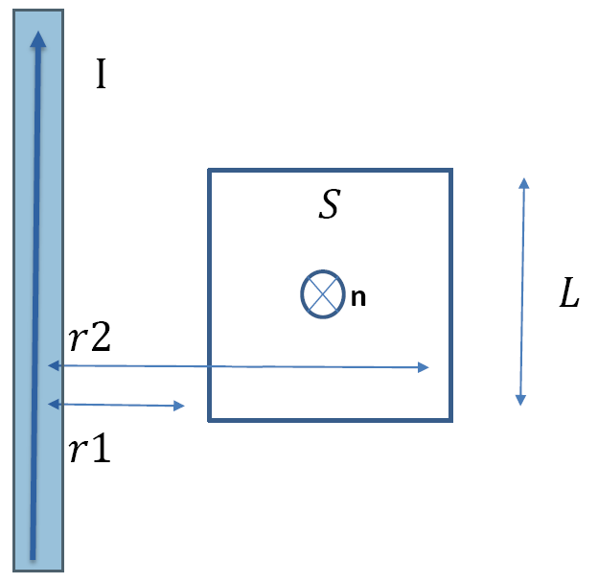

**Figure 3(c)**

(9 marks)

4. (a) The magnetic field component of a plane wave in a lossless dielectric with $μ=μ_{0}$ is:

$$\overline{H}=2\sin\left(2π{10}^{8}t-3x\right){\hat{a}}_{z} mA/m$$

(i) Identify the direction of wave propagation.

(2 marks)

(ii) Identify the direction of the magnetic field.

(2 marks)

(iii) Calculate the dielectric constant $ε_{r}$.

(2 marks)

(iv) Calculate the wavelength, $λ$ and wave velocity $u_{p}$.

(2 marks)

(v) Find the corresponding electric field component $\overline{E}$.

(2 marks)

(b) A transmission line with a length of 0.2λ and a characteristic impedance, $Z_{0}$ of 100 Ω is short circuited. Evaluate the input impedance (*Zin*), voltage standing wave ratio (SWR) and reflection coefficient ($Γ$) of the shorted transmission line with the aid of a suitable diagram.

(15 marks)

END of paper

TABLES OF EQUATIONS

Table 1: Vector relations

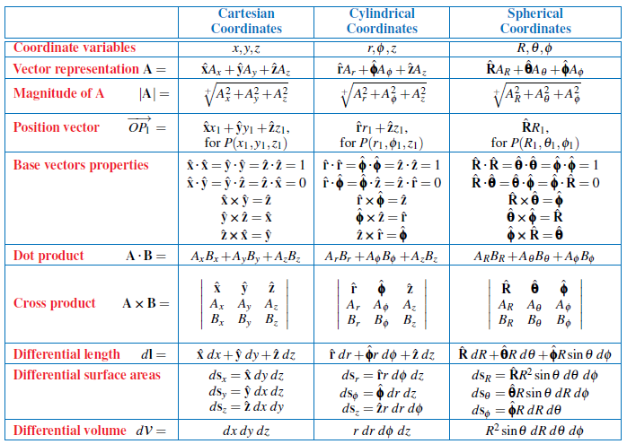

Table 2: Coordinate transformation relations

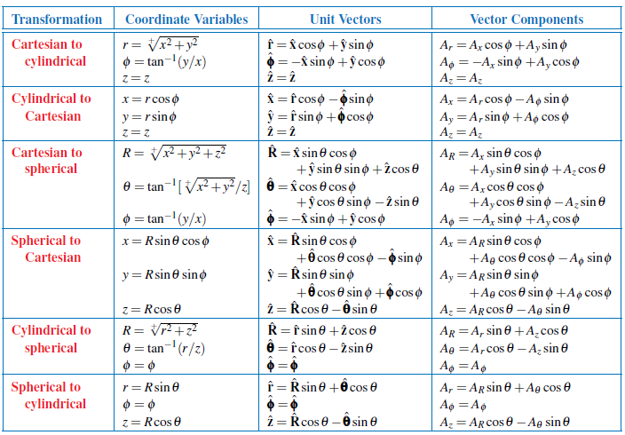

Table 3: Constitutive parameters of materials

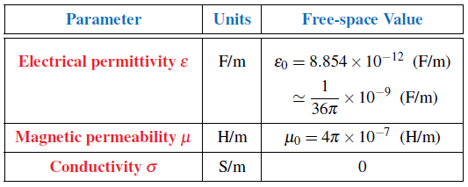

Table 4: Attributes of electrostatics and magnetostatics

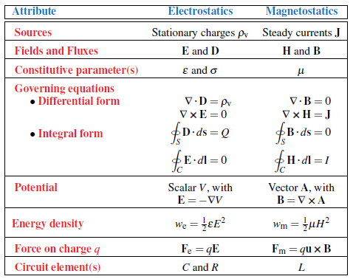

Table 5: Time-invariant fields

|  |  |
| --- | --- |
| Charge Distribution | Electric Field Intensity |
| Point Charge |  |
| Infinite Line of Charge |  |
| Infinite Sheet of Charge |  |
| Current Distribution | Magnetic Field Intensity |
| Infinite Line Current |  |
| Infinite Sheet of Current |  |

Table 6: Transmission-line parameters R’, L’, G’, and C’ for three types of lines.

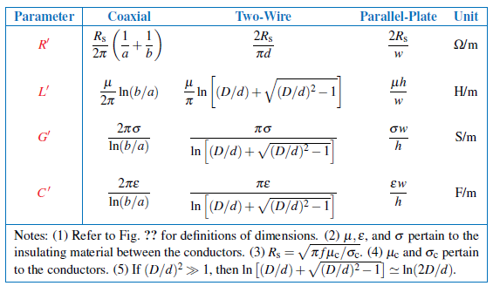

Table 7: Transmission lines and waves parameters

|  |  |  |  |
| --- | --- | --- | --- |
| Voltage Reflection Coefficient |  | Phase constant or wave number, |  |
| Voltage Standing Wave Ratio |  | Wavelength, |  |
| Input Impedance |  | Phase velocity, |  |
| Electric Field |  | Intrinsic impedance, |  |
| Magnetic Field |  | Propagation constant, |  |

Table 8: Characteristic parameters of transmission lines.

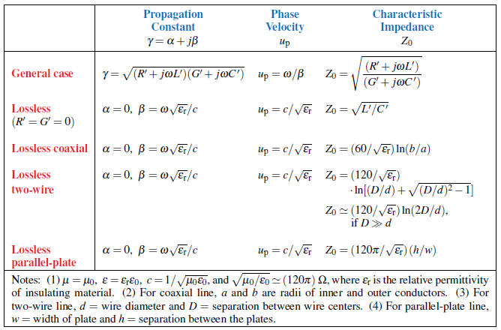

END OF TABLE OF EQUATIONS